Ask Questions to Make Data-Driven Decisions  
**2. Ask**What you will learn?  
-How data analysts solve problems with data  
-The use of analytics for making data-driven decisions  
-Spreadsheet formulas and functions  
-Dashboard basics, including an introduction to Tableau  
-Data reporting basics  
Skill sets you will build:  
-Asking SMART and effective questions  
-Structuring how you think  
-Summarizing data  
-Putting things into context  
-Managing team and stakeholder expectations  
-Problem-solving and conflict-resolution

Week 1:  
**Ask** -> Prepare -> Process -> Analyze -> Share -> Act

Structured thinking: the process of recognizing the current problem or situation, organizing available information, revealing gaps and opportunities, and identifying the option.  
(a vague, complex problem -> smaller steps -> logical solutions)

**Take action with data**

**Solve problems with data**

**SMART Questions (focusing on just one element)**

**X bias X leading questions  
X unfairness X closed-ended question  
X assumptions X vague question**

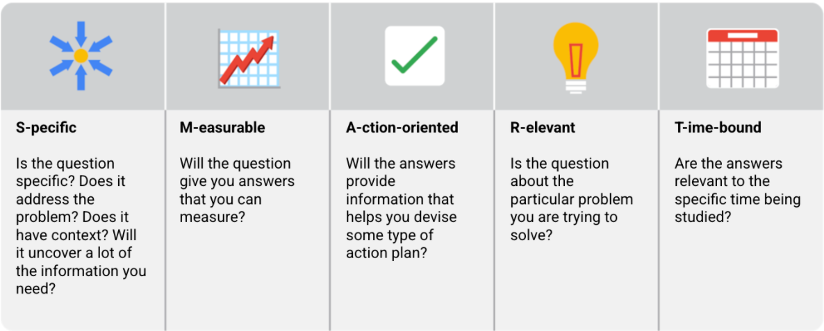

Week 2:

**Quantitative analysis**: specific and objective measures of numerical facts.  
- The what  
- How many  
- How often  
- visualize as charts or graphs  
**Qualitative analysis**: subjective or explanatory measures of qualities and characteristics or things that cannot be measured with numerical data  
- why questions  
- give a more high-level understanding if why the numbers are the way they are  
=> help us add context to a problem

**Presentation tools for data visualization**- reports: a static collection of data given to stakeholders periodically  
- dashboards: monitors live, incoming data

**Pivot table**: A data summarization tool that is used in data processing. Pivot tables are used to summarize, sort, reorganize, group, count, total or average data stored in a database. **Metrics:**- Single, quantifiable type of data that can be used for measurement  
- Be combined into formula that can play your numerical data into  
- Involve into simple math  
 Eg: Revenue = (# of sales) * (the sale price)

**Return on investment (ROI):**- How well an investment is doing  
   
**ROI** = (the net profit over a period of time) / (the cost of investment)

**Filter actions in Tableau:  
Filter actions**=> send information between worksheets  
=> from selected mark to another sheet showing related information  
=> send data value from the relevant source fields as filter to the target sheet  
**Three types of actions:**1) Highlight have a source  
2) Fitler and target  
3) URL -> include field values as dynamics inputs

**Hover:** Runs when you mouse over marks in the view **Select:** Runs when you click marks in the view. Single-select is to avoid running the action when multiple marks are selected   
**Menu:** Runs when you right-click or Control-click a mark in the view, and then click an option in the tooltip menu

**Strategic dashboards:** focus on long term goals and strategics at the highest level of metrics   
Eg: Revenue and customers overview, compared to previous year  
  
**Operational dashboards:** short-term performance tracking and intermediate goals  
- contain information on a time scale of days, weeks, months  
- track and maintain business’s immediate operational process  
  
**Analytical dashboards:** consists of the datasets and the mathematics used in these sets.  
- contain a vast amount of data used by data analyst   
- contain the details involved in the usage , analytics and predictions made.

Week 3:

**Spreadsheets:**- basic and complex calculation automatically  
 Eg: Sum, Average, Count, Min,Max

**Spreadsheets tasks:**- Organize your data  
 Eg: Pivot table  
 - select and filter  
- Calculate your data  
 Eg: Formula, Functions

**Data life cycle:**

**Spreadsheet errors:  
1. #DIV/0!**=> false calculation  
 Eg: 0/0 => DIV/0!  
=IFERROR(B4:A4, “Not applicable”)

**2. #ERROR!**  
=> No comma between cell ranges

**3. #N/A!**  
=> Data in formula cannot be found by the spreadsheet  
=VLOOKUP(loopup_value, cell ranges: cell ranges, column no.,True/False)  
  
**4. #NAME?**  
=> the name isn’t understood  
Eg. =VLOOOKUP (one extra O)

**5. #NUM!**  
=> calculation can’t be performed  
Eg. =DATEDIF(B6,C6, “M”)

**6. #VALUE!**  
=> a problem with a formula or referenced cells  
  
**7. #REF!**  
=> a referencing cell is no longer valid or has been deleted

**A scope of work (SOW):**  
- To make sure that everyone involved, from analysts and engineers to managers and stakeholders, shares the understanding of what those business goals are, and the plan for accomplishing them.

**Deliverables:**  
- What work is being done;  
- What things are being created as a result of this project;  
- When the project is complete;  
- What are you expected to deliver to the stakeholders;  
- Will you collect data for this project? How much, or for how long?   
  
 **Milestones:**  
- What are the major milestones for progress in your project;  
- How do you know when a given part of the project is considered complete?  
  
**Timeline:**   
- When will the deliverables be completed;  
- How long do you expect the project will take to complete;  
- If all goes as planned, how long do you expect each component of the project will take;  
- When can we expect to reach each milestone?  
  
**Reports:**   
- How will you communicate progress with stakeholders and sponsors, and how often;  
- Will progress be reported weekly? Monthly?   
- When milestones are completed;  
- What information will status reports contain?

**Staying objective:**

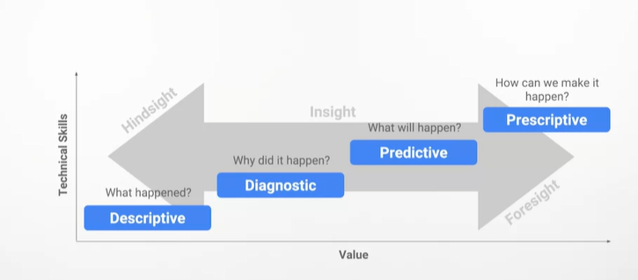

**The importance of context:**  
- Context can turn raw data into meaningful information.

Week 4:  
  
**Focus on what matters**1) Who are the primary and secondary stakeholders?  
2) Who is managing the data?  
3) Where can you go for help?

**Updated timeline email sample**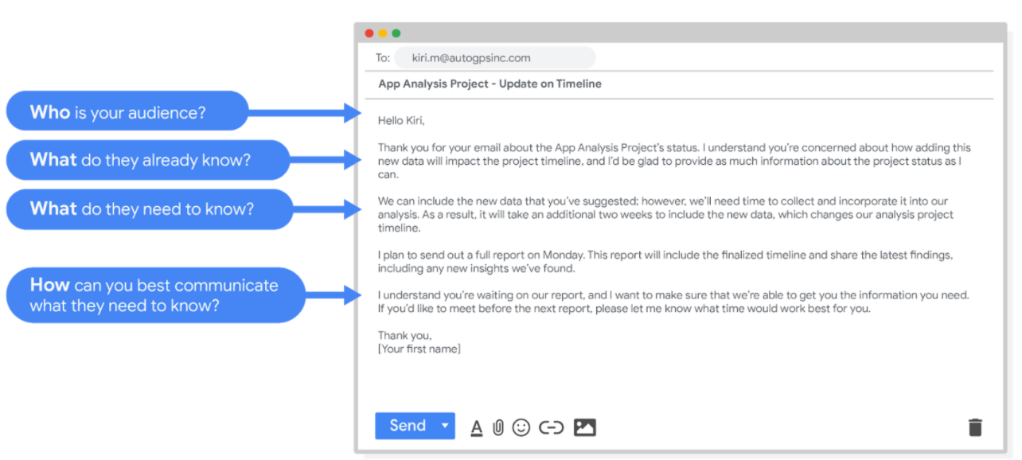

**Project follow-up email sample**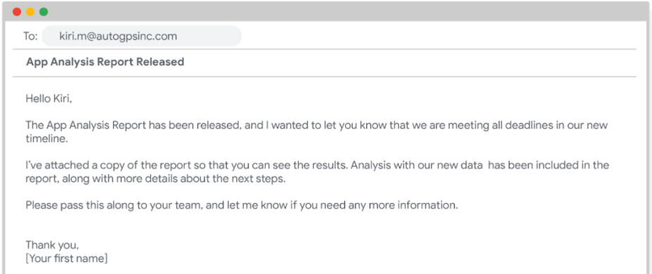

**Setting goals:**1) Who are the primary and secondary stakeholders?  
2) Who is managing the data?  
3) Where can you go for help? **Balancing expectations and realistic projects goals:**1) Set a reasonable and realistic timeline for the project  
2) Flag problems early for stakeholders  
3) Set realistic expectations at every stage of the project **Limitations of data:**1) The case of incomplete or nonexistent data  
2) Don’t miss misaligned data  
3) Deal with dirty data  
4) Tell a clear story  
5) Be the judge